East West University

Semester: Fall-2025
Course Title: Software Architecture
Course Code: CSE423 Sec: 01

Assignment on Architectural Design

Submitted by-
Sheikh Sarafat Hossain (2022-3-60-109)
Rijia Parveen Raya (2022-3-60-192)
Mashiur Rahaman Mollah Niran (2022-3-60-183)
Md Adnan (2022-3-60-179)

Submitted to-
Ahmed Adnan
Lecturer
Department of Computer Science & Engineering

Date of Submission: 26th December 2025
- Architectural Context Diagram (ACD):
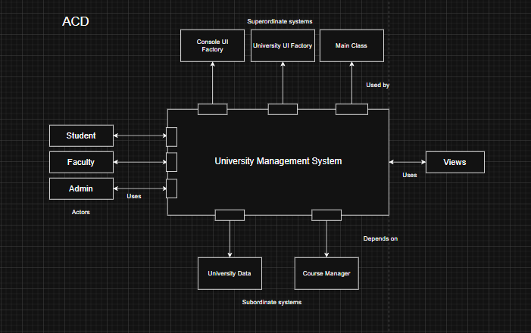
- Defining the Archetypes:
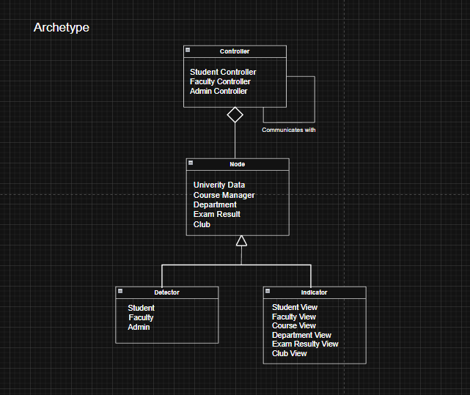

- Refinement of the initial architecture into components:
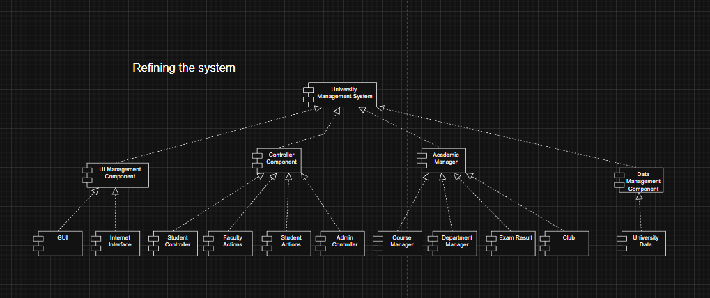
- System Architecture Design:
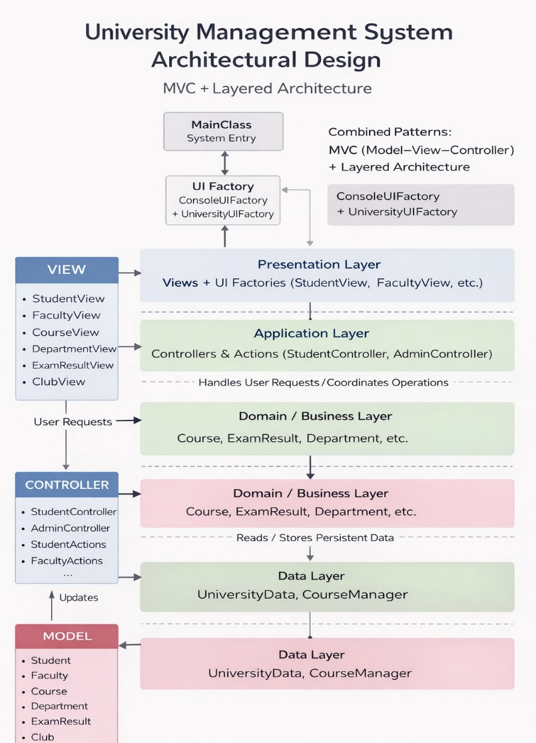
Link: https://drive.google.com/file/d/1PH0T6CKe2x7h-e5nCgw5CAmryqrRpxJF/view?usp=sharing

